Summary report

8th Strategy Forum of the EUSBSR in Berlin 13 – 14 June

Seminar: Creating the future of the Baltic Sea Region (BSR): Better competitiveness through joint research cooperation?

Time: Tuesday, 13 June, 17:00 to 18:30 hours, Adenauer-Saal
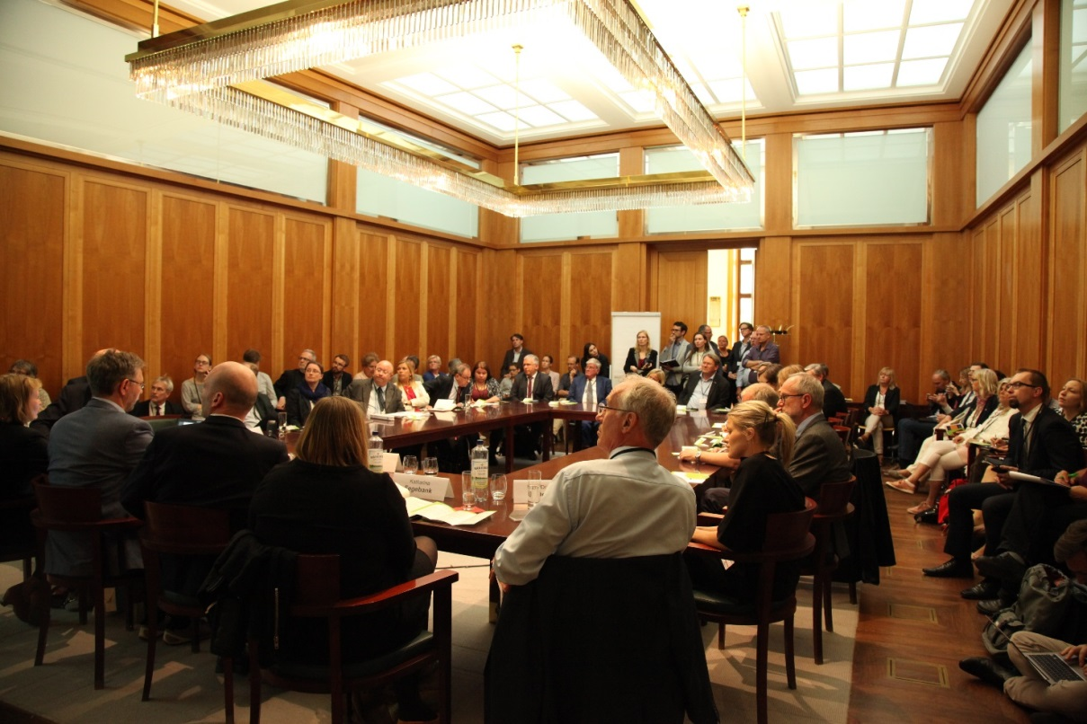

Katharina Fegebank, Minister of Science, Research and Equalities of Hamburg, welcomed attendants of the Baltic Science Network (BSN) session by outlining the unique character of the transnational platform due to its notable scope of membership. These inspiring remarks were followed by a brief introduction to the Network´s goals, macro-regional added value and expanding membership presented by the BSN Project Director Klaus Von Lepel, Ministry of Science, Research and Equalities of the Free and Hanseatic City of Hamburg.
In order to provide a more thorough background for further discussion of research mobility trends, a number of most recent findings were presented. Namely, Dr. Tom Schumacher presented statistics on how competitive are the Baltic Sea Region states in terms of academic referencing statistics. Consequently, Prof. Dr. Kazimierz Musial, representing the Scientific Foundation Norden Centrum, provided first insights in the on-going research of Baltic Sea Region (BSR) areas of research excellence which will facilitate the reflection
process among the BSN members on chosen focus areas. The initial findings indicate that there might be a strong focus on life sciences, marine sciences and climate change.
Summary report

The second half of the seminar was dedicated to the panel discussion which gathered Minister Katharina Fegebank, as well as an outstanding set of speakers representing some of the leading BSR research centres and research supporting institutions. Prof. Dr. Robert Feidehans´l, Director of the European XFEL, Prof. Dr. Helmut Dosch, Chairman of the DESY Board of Directors, Dr. Kaisa Kononen, Executive Director of BONUS, and Lone Jessen, representing NordForsk, discussed what research excellence means in the BSR setting and how an additional support through enhanced researcher mobility would help the macro-region to excel in the European and international setting. In response to the question regarding the increased competition among countries in terms of research performance Minister Katharina Fegebank and Prof. Dr. Helmut Dosch outlined the long-standing positive effects of vibrant competition among scientists, since it has contributed to the scientific excellence housed in the BSR today. Prof. Dr. Robert Feidehans´l commended the NordForsk Summer Schools as a best practice example in terms of transnationally facilitated researcher mobility. Dr Kaisa Kononen highlighted that the most recent BONUS impact study testifies to the added value of transnational cooperation as an enabler of research excellence, thus also contributing to BSR´s capacity to respond to the contemporary challenges identified on the European and international level. The time-wise demanding process of crafting quality support structures was highlighted by Dr Kaisa Kononen, reminding to the BSN audiences that it took 10 years to prepare the establishment of BONUS Programme.
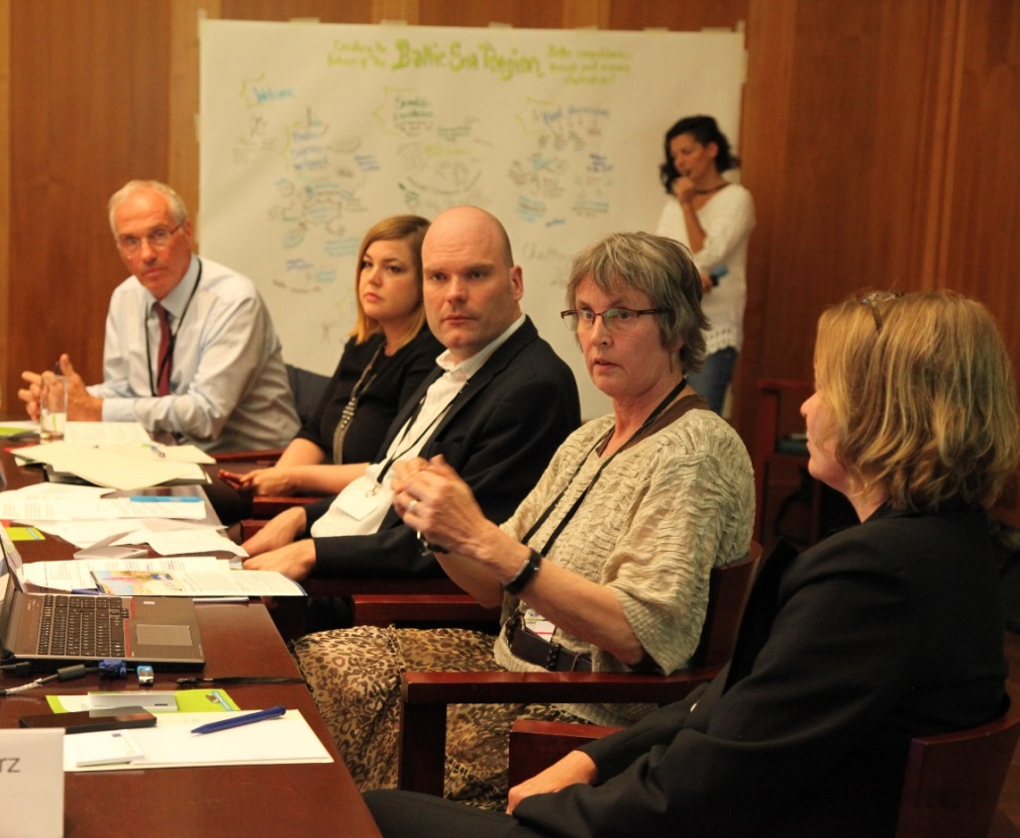
During the concluding phase of the session Minister Katharina Fegebank highlighted the importance of building closer ties with the society to ensure the overall awareness how the considerable investments in science made today will help to successfully address the societal challenges. It is clear that research investments will not reach their full impact without the public support. Therefore, the cause advanced by the Baltic Science Network would greatly benefit from being renowned not solely on the European but also on the international scale.
Photos of the Baltic Science Network session are accessible on the CBSS album dedicated to the 8th Annual Forum of the EUSBSR here.

